**Experiment no- 03**

Name: Suraj P. Patil

Roll No: 3034

URN: 20131086

Class: TY(A)

Batch: T-2

**Title:**

*Draw a use-case diagram.*

Use Case Diagram for YouTube:

1. User Registration: A user creates an account on YouTube to access various features like creating, uploading, and sharing videos.
2. Search for Videos: A user searches for videos on YouTube using keywords, tags, or categories.
3. Watch Videos: A user watches a video on YouTube, which may include playing, pausing, or seeking the video.
4. Like/Dislike Videos: A user can like or dislike a video on YouTube.
5. Comment on Videos: A user can leave a comment on a video they have watched.
6. Upload Videos: A user can upload videos to their YouTube channel.
7. Manage Channel: A user can manage their YouTube channel by changing settings, creating playlists, and managing videos.
8. Monetize Videos: A user can monetize their videos by enabling advertisements and earning revenue.
9. Subscribe to Channels: A user can subscribe to channels to get updates on new videos.
10. Share Videos: A user can share videos with others through social media or email.

These are some of the common use cases for YouTube. The use case diagram helps to identify the different actors involved and the interactions between them.

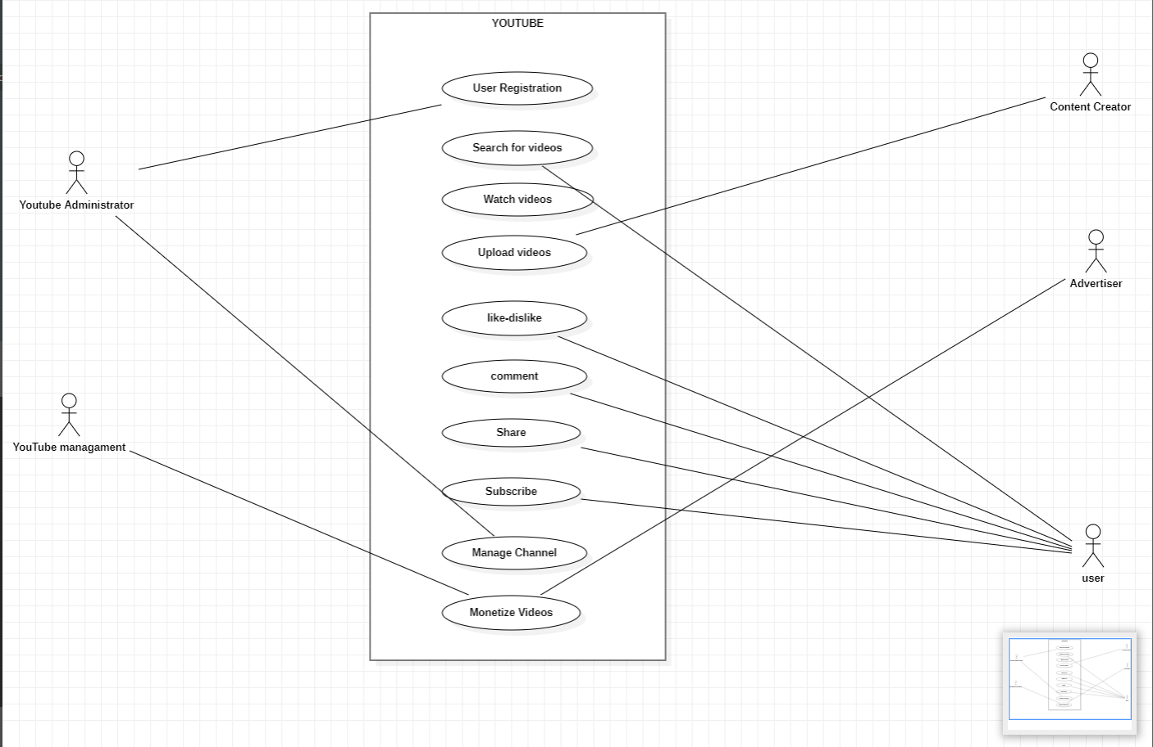

The actors in the above use case diagram for YouTube would typically include:

1. User: The primary actor who creates an account, searches for videos, watches videos, likes or dislikes videos, comments on videos, uploads videos, manages their channel, subscribes to channels, and shares videos.
2. YouTube System: The system that provides the platform for users to access and interact with the videos. This system includes features such as search, video playback, commenting, uploading, channel management, monetization, and social sharing.
3. Advertisers: The actors who use YouTube's advertising platform to display ads on videos and generate revenue.
4. Content creators: The actors who create videos and upload them to YouTube to share with their audience.
5. YouTube administrators: The actors who manage and maintain the YouTube platform, ensure compliance with policies and guidelines, and monitor content for potential violations.

These actors interact with each other to accomplish the different use cases mentioned in the use case diagram for YouTube.